1. **Steps for creating SECRETS From the section AWS security manager :-**

**a. Go to AWS console page**

**b. Search for AWS security manager interface page at search bar option**

**c. Choose SECRET TYPE from left side of the page**

**d. Next CONFIGURE secret type like as shown below images**

**e. By adding some credentials at required tabs shown below**

1. **After entering all finally select create tab ..**
2. **AND create IAM ROLE for the purpose of Access And Secret key**
3. **COPY THE key and save it for further use at AWS CLI MODE TO COFINUGRE TH CLI IN COMMAND PROMT . :-**

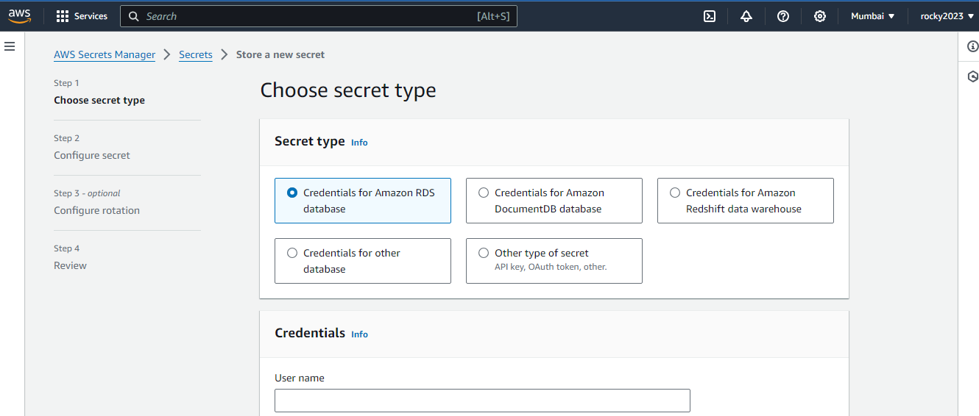

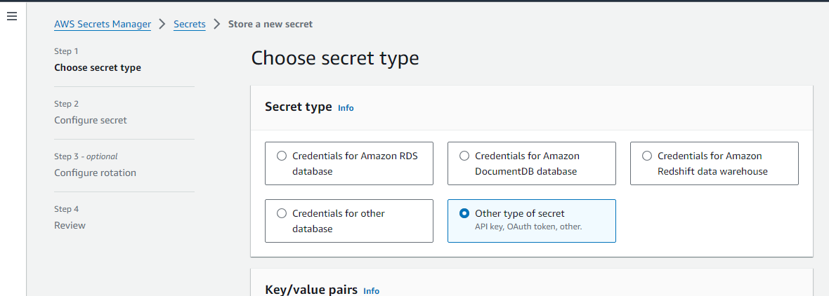

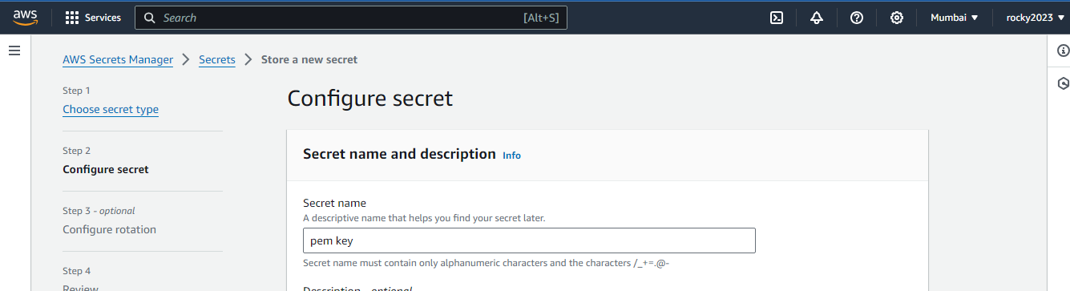

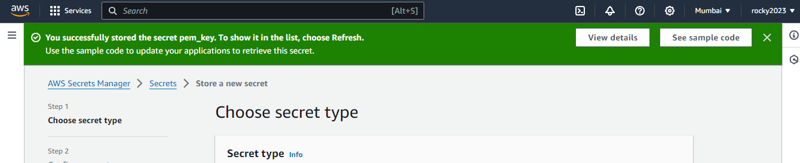

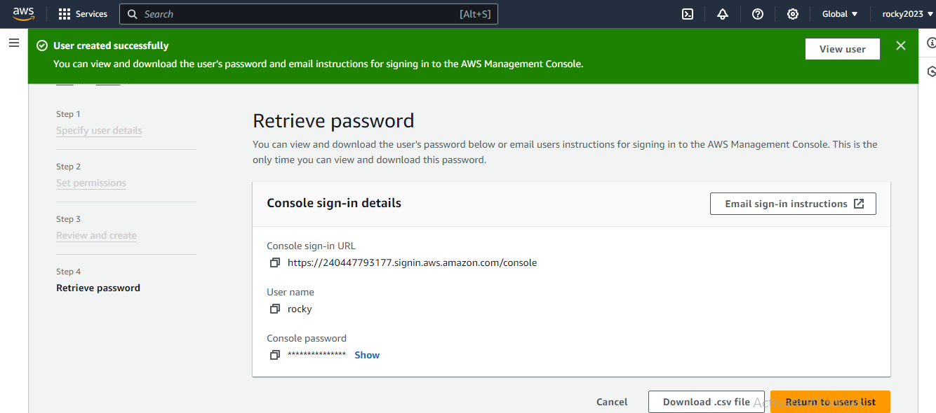

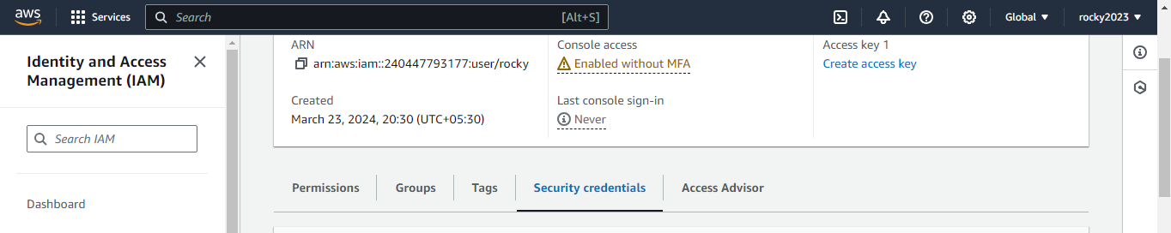

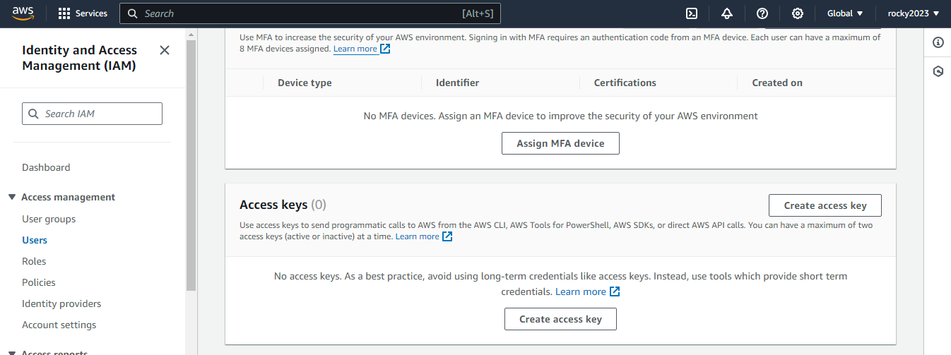

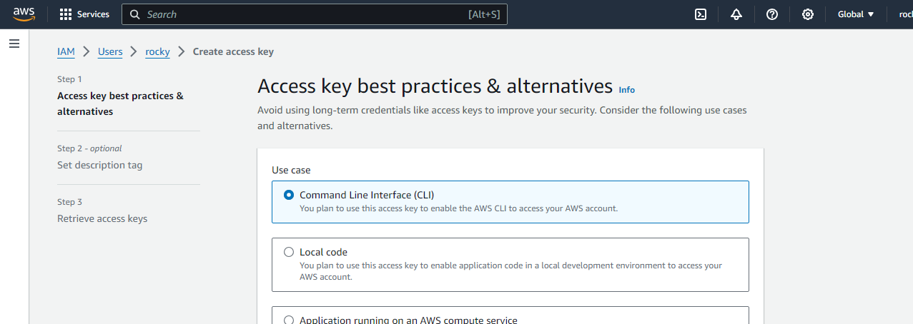

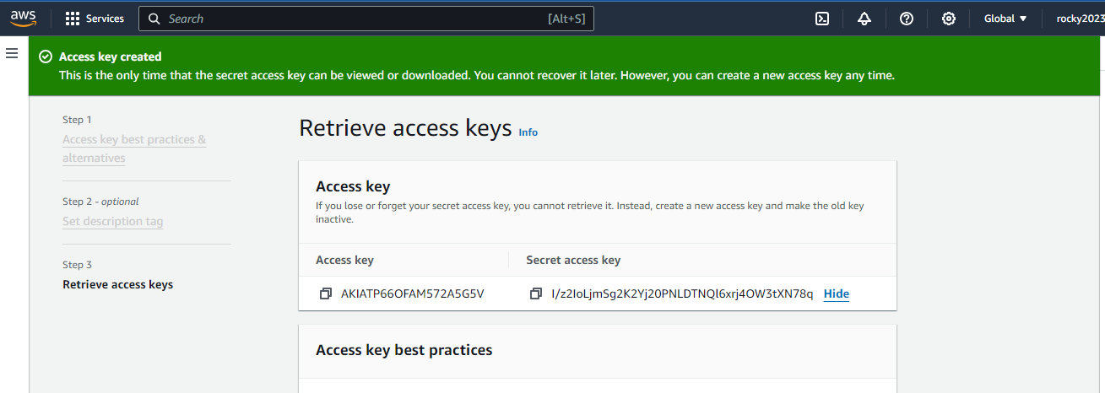

1. **Next get in to the command prompt of bash**
2. **CHECK aws version by proper aws commands**
3. **Next configure the AWS IN BASH CLI**
4. **After Confirm the figure next**
5. **aws secretsmanager get-secret-value --region ap-south-1 --secret-id pem_key**
6. **After entering the above command to retive the secret key from aws console to comman line interface . :-**
7. **Below images shown clearly secret pem key retrived..**

